ASSIGNMENT 9.4
Name:k.uma maheshwari
2303a52430
Batch : 44
1: Task 1: Auto-Generating Function Documentation in a Shared Codebase
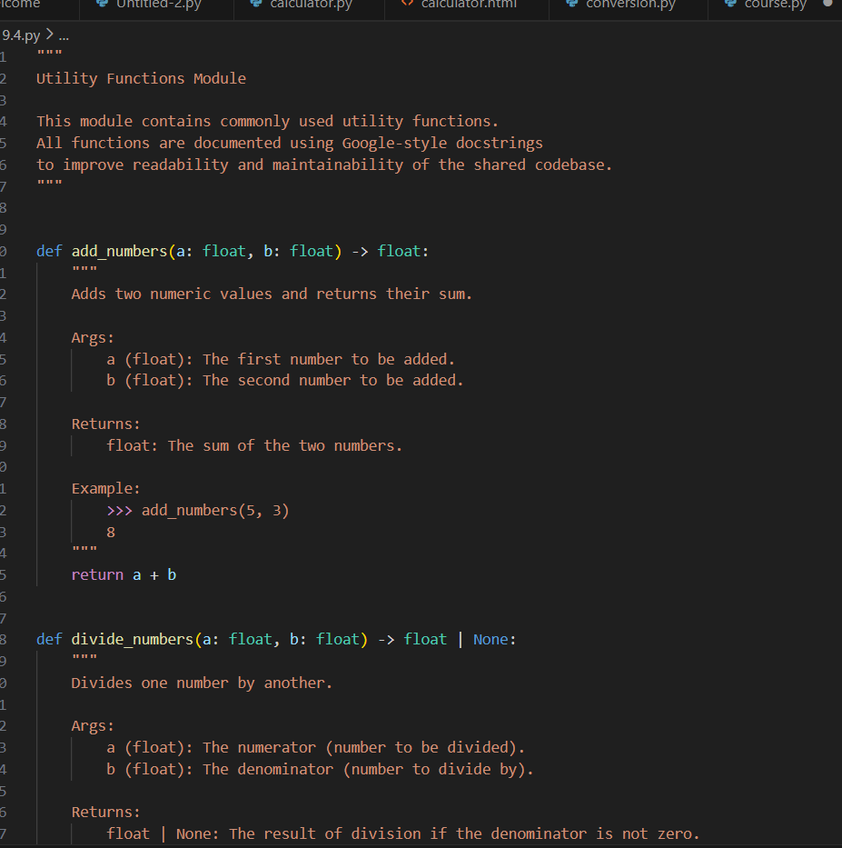
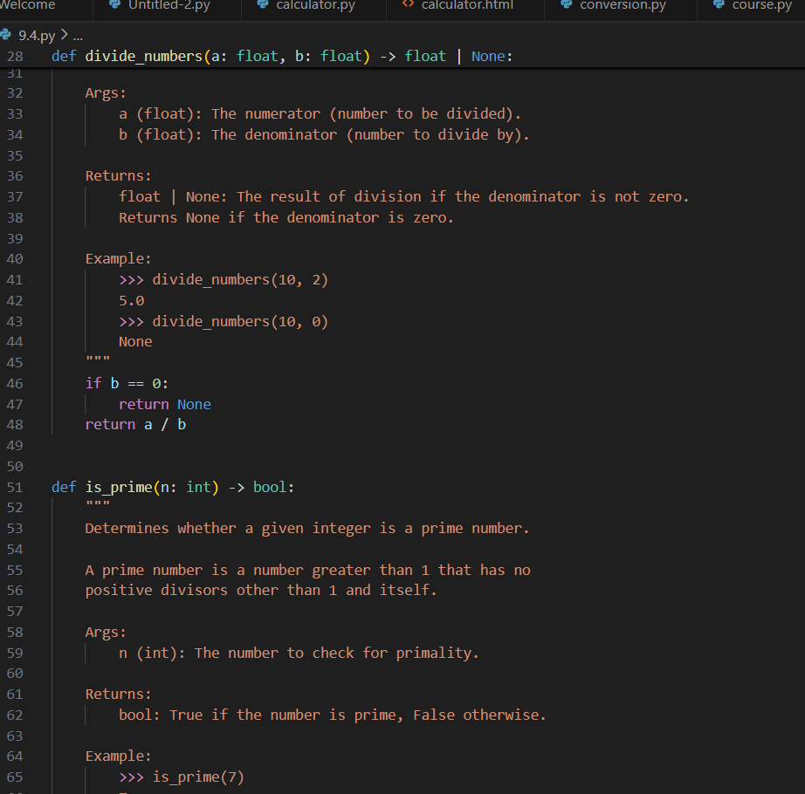
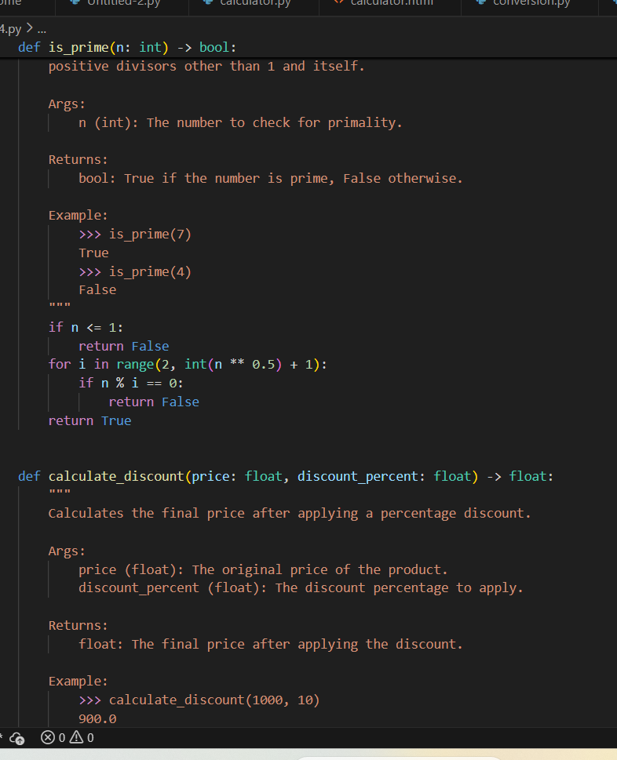
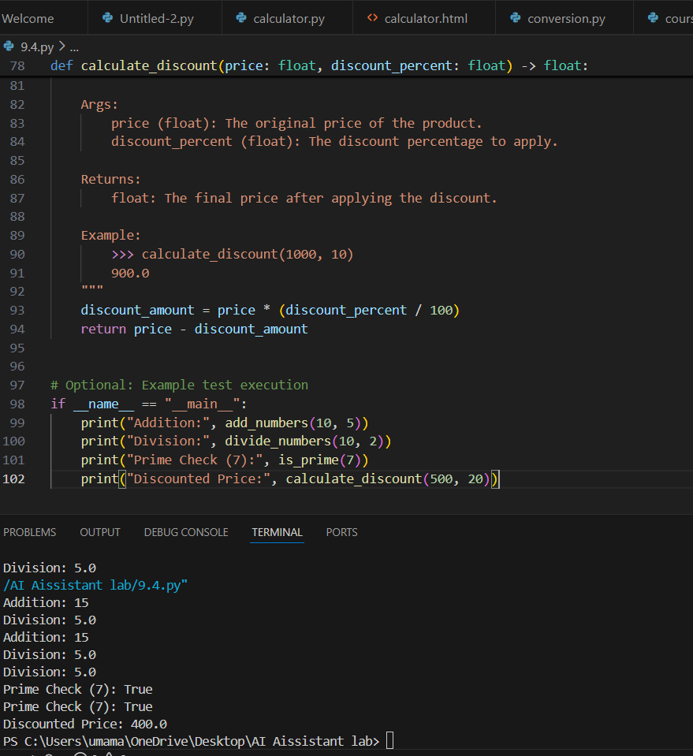

Task 2: Enhancing Readability Through AI-Generated Inline Comments
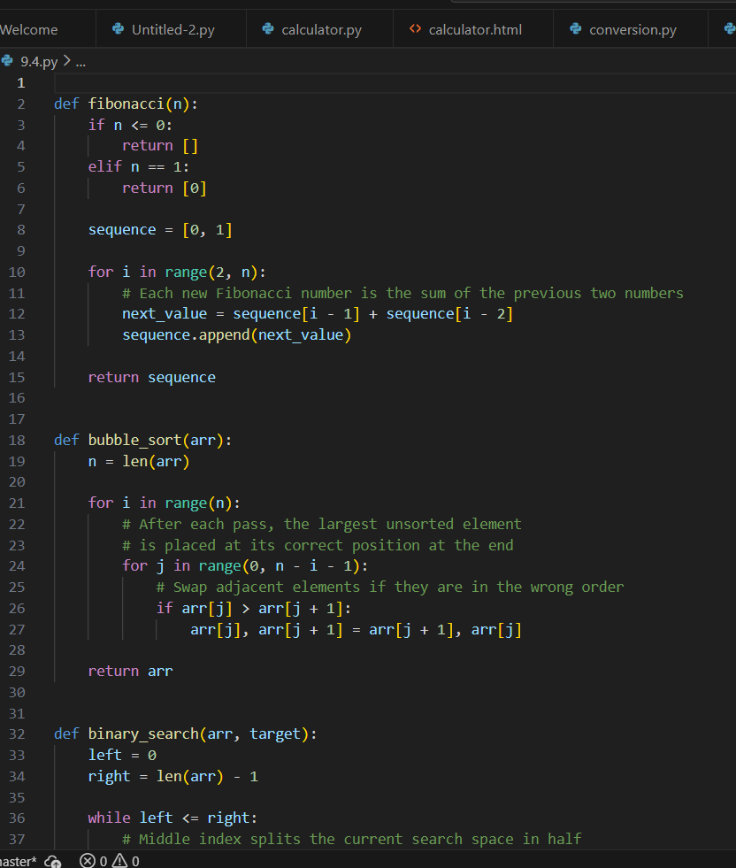
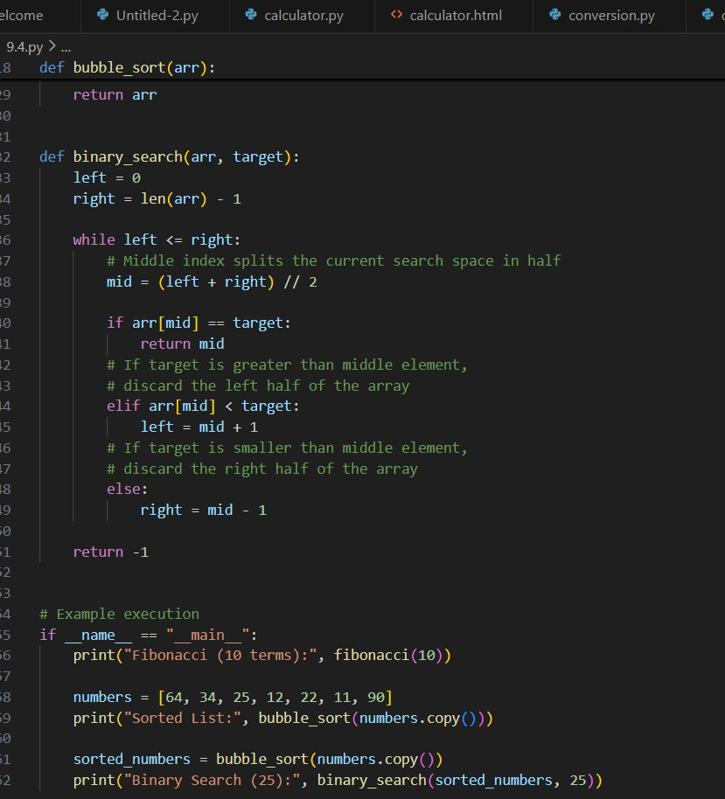
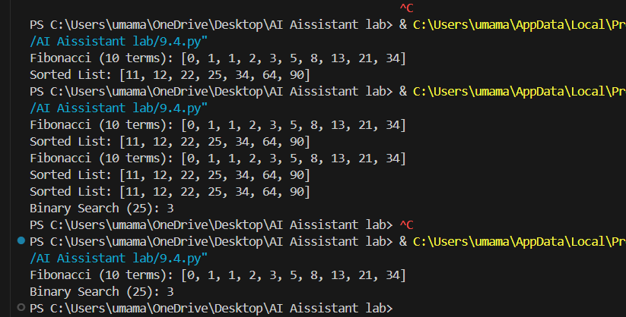
Task 3: Generating Module-Level Documentation for a Python Package
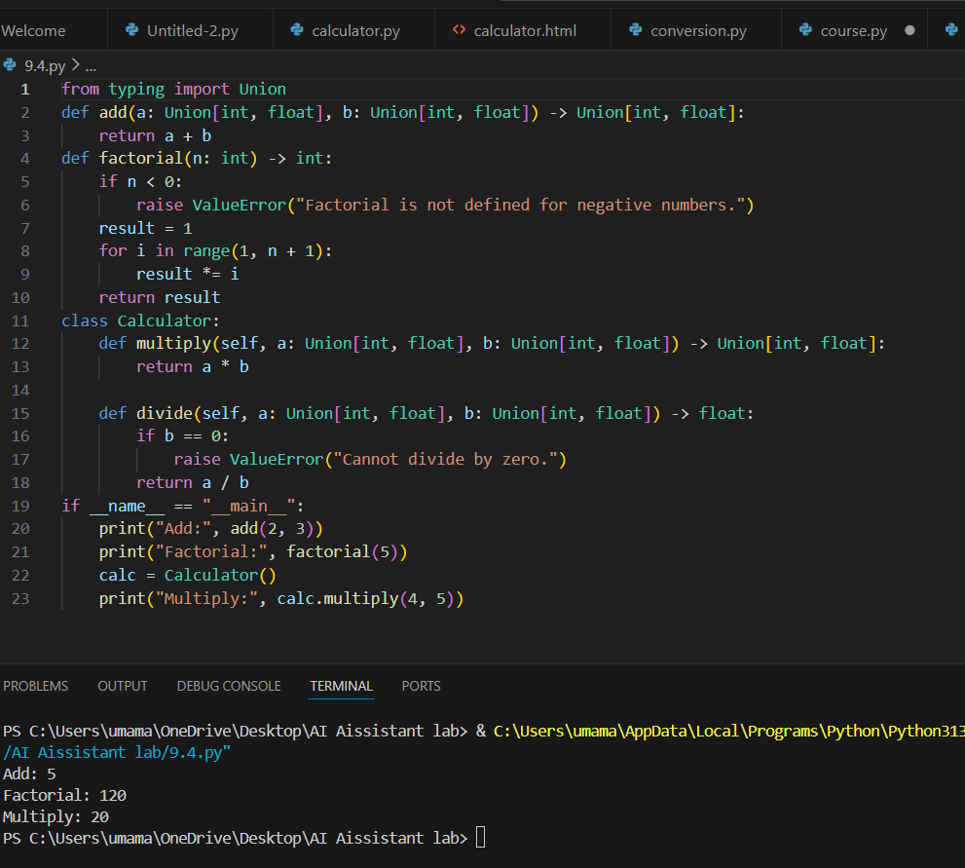

Tsk4: Converting Developer Comments into Structured Docstrings

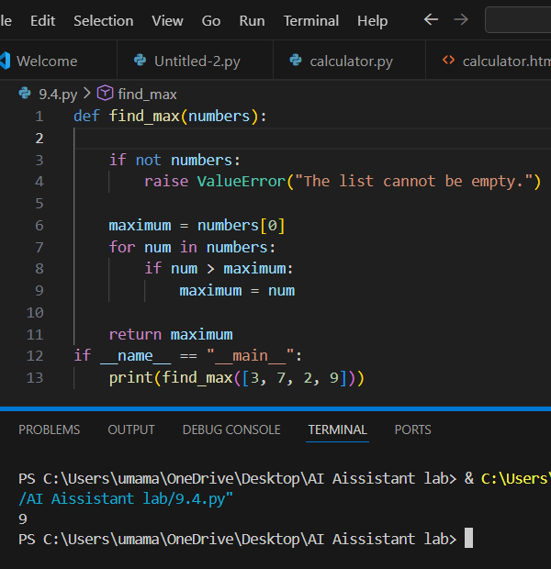

Task 5: Building a Mini Automatic Documentation Generator
